FINAL TEST REPORT
AND SOLUTION DESCRIPTION
MVP module for intelligent anomaly detection in oil production
(Tubing String Leak, Inflow)
Appendix to Contract No. 1
(deliverables per clauses 3.3–3.6, 5.3 of the Statement of Work)
2026

CONTENTS
1 Purpose and Composition of the Module (clause 3.1) 4
2 Source Data and Sample Composition (clause 3.2) 4
2.1 Quantitative Composition of the Sample 4
2.2 Data Flows and Artifact Locations 5
3 Input and Output Parameters 6
3.1 Input Parameters 6
3.2 Output Parameters 7
4 Solution Architecture and Models Used 8
4.1 Normality Reference Encoder (Neural Network Model, PaAno Architecture) 8
4.2 Normal-Behavior Reference Bank (Shared) 8
4.3 Anomaly Onset Detection Layer 9
4.4 Physical Criteria by Anomaly Type 9
5 Composition of the Deliverables (clause 3.3) 9
6 Instructions for Launch, Testing, and Use (clause 3.4) 10
6.1 Environment Setup 10
6.2 Building the Dataset from the Customer's Exports 10
6.3 Training the Normality Reference (If Retraining Is Required) 10
6.4 Detection on Labeled Wells 10
6.5 Detection on New Wells (Blind Run over an Export Directory) 11
6.6 Report Generation 11
7 Test Results and Quality Metrics (clause 3.5) 11
7.1 Methodology and Metric Definitions 11
7.2 Blind Test on the Customer's Data 12
7.3 Control Check on Labeled Data 12
7.4 Visualization of Results 13
8 Recommendations for Further Development (clause 3.6) 17
8.1 Expanding the List of Detected Anomalies 17
8.2 Improving Quality for Existing Types 17
8.3 Deployment into the Production Environment 17

1 Purpose and Composition of the Module (clause 3.1)
An MVP software module for intelligent anomaly detection in oil production has been developed, operating on the telemetry of electric submersible pump (ESP) units. The module analyzes time series of well field telemetry and detects two agreed anomaly types, determining both the presence of an anomaly and its onset time.
Tubing string leak — an abrupt failure event: a step-like rise in pump intake pressure while the pump is running. The indicator is a sharp relative step in pressure; temperatures and currents may respond but are not required. The anomaly has no precursor — the abrupt change itself is the event, so the onset is fixed at the step.
Inflow — a change in the inflow of formation fluid: a sustained intake-pressure trend (upward or downward) at a stable output frequency, with no signs of pump performance degradation. The main indicator is the pressure trend; output frequency serves as a regime control.

2 Source Data and Sample Composition (clause 3.2)
The module is run and has been tested on data provided by the Customer — tabular exports of well field telemetry. Processing is fully autonomous and does not call any external services (it operates without a network connection). All exports are brought to a common 5-minute time grid and a common set of parameters.

2.1 Quantitative Composition of the Sample
The table below gives the distribution of wells by purpose (normality reference training — internal validation — external blind test). The normality reference is understood as a model of the well's normal behavior; it is trained on normal regimes, so training uses normal wells and normal well segments prior to anomaly onset.
Table 1 — Distribution of Wells by Purpose
Type / purpose | Provided | Normality reference training | Internal validation | External blind test | Excluded (data hygiene)
Inflow | 33 | 24 | 2 (wells 3138, 5021) | 7 (42-713, 42-723, 45-790, 46-806, 48-812, 1071, 590) | —
Tubing leak | 4 | 2 (172g, 3509g) | 1 (524) | 1 (524) | 1 (5271g)
Normal operation (normality reference) | 23 | 23 | — | — | —

Notes on the table. For inflow, of the 33 wells, 26 are expert-labeled (24 for training, 2 for internal validation), and another 7 were provided without labels specifically for the blind test (inflow was detected in 6 of them; well 590 has no anomaly, which confirms the absence of false alarms on a normal well). For tubing leak, 4 labeled wells were provided: two (172g, 3509g) were used to train the normality reference, one (524) was placed in the blind test — the model did not use it during training — and one (5271g) was excluded from the normality reference (an ambiguous downward pressure trend was found in its "normal" segment, which is a data-hygiene measure rather than an error). The normality reference was supplemented with 23 normal wells: 20 in regular operation and 3 with normal regime changes (output-frequency changes), needed to distinguish the response to a regime change from an anomaly.

2.2 Data Flows and Artifact Locations
The data path from the source exports to the per-well report:
Table 2 — Data Flows and Artifact Locations
Stage | Input | Program | Output
Dataset assembly | data/raw/<type>/*.xlsx (exports) | scripts/datasets/build_combined_summary_datasets.py | db/<type>_anomaly_database_5min.parquet; db/<type>_intervals.parquet; db/norm_work_database_5min.parquet
Normality reference training | db/*.parquet | scripts/utils/build_population_memory_bank.py | models/global_normality_paano_shared_encoder.<class>.pt; models/population_memory_bank_paano_global_global_normality.<class>.npz
Detection | well export + models/ | scripts/detection/detect_<type>.py; scripts/detection/detect_test_wells_batch.py | artifacts/.../<well>/<type>/source.parquet, scores.parquet, predicted_starts.parquet, summary.json
Report | artifacts/.../ | scripts/reports/generate_test_wells_report.py | artifacts/reports/*.html (standalone web page)

3 Input and Output Parameters

3.1 Input Parameters
Up to 26 channels are available in the tabular telemetry export. The model uses 21 channels — a strict common channel set. It includes only channels present with completeness of at least 95% in every well of all classes (tubing leak, inflow, scaling, normal operation). This selection guarantees a uniform input set for any well and was made by data availability, not by feature importance. All 21 channels are fed to the model (including output frequency).
Table 3 — Model Input Channels (21 channels)
Group | Channels (21 in total)
Pressure | pump intake pressure (kgf/cm²)
Temperatures | at the pump intake; motor oil (°C)
Currents and load | phase currents A, B, C; current imbalance; SEM load factor; total output power
Voltages | line-to-line AB, BC, CA; phase Ua, Ub, Uc; voltage imbalance
Vibrations | along the X, Y, Z axes and total XYZ
Operating mode | output frequency

Of the 26 export channels, 5 are not fed to the model due to incomplete coverage (a channel is missing in at least one well of one of the classes, or its completeness is below 95%):
Table 4 — Export Channels Not Used by the Model
Not used | Reason
Cos φ | missing in at least one scaling well
Active output power | missing in at least one inflow well
Vibration XY | missing in at least one inflow well (the X, Y, Z, XYZ axes are covered — retained)
VFD output current | missing in at least one inflow well
VFD DC-link voltage | missing in inflow wells; in scaling wells completeness is below 95%

The most important features are intake pressure, temperatures, phase currents, and the SEM load factor; expert interpretation of the result relies on them. A separate experiment reduced to these 7 channels showed comparable quality; however, the production configuration uses all 21 channels for robustness.

3.2 Output Parameters
For each well, the module produces a summary and a point-by-point result. Main summary fields:
Table 5 — Main Summary Fields
Field | Description
detected_starts | list of anomaly onset times (date-time)
n_detected | number of detected anomaly onsets
n_actionable_detected | number of points with an actionable alert
n_incidents | number of incidents (grouped episodes)
score_min / score_median / score_max | anomaly-score statistics over the series
time_start / time_end | bounds of the processed series interval

The point-by-point result (for each 5-minute point) additionally contains:
Table 6 — Point-by-Point Result Fields
Field | Description
score | anomaly-score value (deviation from the normality reference)
quality_status | data quality status (normal / artifact)
regime_status | regime status (normal / transition)
zone_status | zone status (clean normal / pre-failure zone)
event_class | event class (warning / anomaly candidate)
actionable_alert | actionable-alert flag
incident_id / incident_state | incident identifier and state

4 Solution Architecture and Models Used
The solution is built on the principle of detecting anomalies as deviations from a reference of the well's normal behavior. This approach does not require labeling failures in advance: the model is trained on normal regimes and reacts to departures from them. The solution consists of four layers.

4.1 Normality Reference Encoder (Neural Network Model, PaAno Architecture)
The neural network model encodes the well's multichannel telemetry in sliding windows of two scales — short and long (about 16 and 32 hours; at a 5-minute step this is 192 and 384 samples). The model is trained exclusively on normal operating regimes (fully normal wells and normal well segments prior to anomaly onset) and outputs a compact representation of the well's behavior in each window.

4.2 Normal-Behavior Reference Bank (Shared)
A single (shared) bank of normal-behavior patterns, built across the well fleet: from fully normal wells and from normal well segments prior to anomaly onset. The bank represents one common operating norm and is used for all anomaly types — the anomaly score of each point in the series is computed as the distance of its pattern from the normality bank. Only those segments for which the absence of an unlabeled anomaly cannot be guaranteed are excluded from the bank (a data-hygiene measure), not for the sake of separating anomaly types.

4.3 Anomaly Onset Detection Layer
A causal (past-only) algorithm detects a sustained deviation of the anomaly score from the baseline level. The threshold is calibrated on each well's reference segment with control of the false-alarm rate; confirmation requires the deviation to be sustained, which filters out isolated outliers.

4.4 Physical Criteria by Anomaly Type
On top of the neural-network score, physically interpretable rules are applied to make the result explainable to an expert.
Inflow — a sustained intake-pressure trend at a stable output frequency (a combined criterion of "pressure trend + neural-network score"); the onset is placed at the start of the trend.
Tubing leak — a sharp relative step in intake pressure (a rise of at least 10% within up to 6 hours), outside zones of full pump shutdown; the onset is placed at the step itself. The threshold is relative (as a percentage of the given well's pressure level), so the criterion is universal and requires no per-well tuning.

5 Composition of the Deliverables (clause 3.3)
The following is delivered to the Customer:
- Program code (source code) of the module: the processing and detection library, dataset assembly from exports, normality-reference training, and scripts for running detection and generating reports.
- Trained models: the normality-reference encoder and the normal-behavior reference bank (files in the models/ directory).
- Reporting materials: interactive per-well reports as standalone web pages with telemetry charts and marked anomaly onset times; this final test report.

6 Instructions for Launch, Testing, and Use (clause 3.4)
The full sequence of commands is given below. Commands are run from the project root directory. Directories: data/raw — source exports; db — assembled datasets; models — trained models; artifacts — detection results and reports.

6.1 Environment Setup
Create a Python virtual environment and install the dependencies:
python3 -m venv .venv
source .venv/bin/activate
pip install -r requirements.txt

6.2 Building the Dataset from the Customer's Exports
Bring the tabular exports to a common 5-minute grid and parameter set. The input is the summary labeling table and the export directories; the output is datasets in the db/ directory:
python scripts/datasets/build_combined_summary_datasets.py \
--summary data/reference/<summary>.xlsx \
--freq 5min

# result:
# db/pritok_anomaly_database_5min.parquet, db/pritok_intervals.parquet
# db/negermet_anomaly_database_5min.parquet, db/negermet_intervals.parquet
# db/norm_work_database_5min.parquet

6.3 Training the Normality Reference (If Retraining Is Required)
Trained models are included in the delivery package. The normality reference can be retrained for the target class with the command:
python scripts/utils/build_population_memory_bank.py \
--detector paano_global --anomaly pritok # or --anomaly negermet

# result (models/ directory):
# global_normality_paano_shared_encoder.<class>.pt
# population_memory_bank_paano_global_global_normality.<class>.npz

6.4 Detection on Labeled Wells
python scripts/detection/detect_pritok.py --detector paano_global
python scripts/detection/detect_negermet.py --detector paano_global

6.5 Detection on New Wells (Blind Run over an Export Directory)
Place the exports (one file per well) in a directory and run batch detection for the required anomaly type. The appropriate pair of models is selected automatically by type:
python scripts/detection/detect_test_wells_batch.py \
--xlsx-dir data/raw/<exports_dir> \
--output-root artifacts/<run_name> \
--detector paano_global \
--anomalies pritok \ # or negermet
--use-population-memory-bank

# result per well:
# artifacts/<run_name>/<well>/<type>/summary.json (presence and onset of the anomaly)
# ... scores.parquet, predicted_starts.parquet, source.parquet

Detection for a single well can be run directly:
python scripts/detection/detect_negermet.py --well 524 --detector paano_global

6.6 Report Generation
python scripts/reports/generate_test_wells_report.py \
--batch-dir artifacts/<run_name> \
--anomalies pritok \
--output artifacts/reports/<name>.html

7 Test Results and Quality Metrics (clause 3.5)

7.1 Methodology and Metric Definitions
Detection recall — the share of labeled anomalous intervals for which the model produced a trigger within the interval. False-alarm rate — the number of triggers in the normal zone, normalized to one day. Detection delay — the time difference between the moment marked by the model and the expert-labeled anomaly onset (for inflow) or the pressure-step moment (for tubing leak). Blind test — evaluation on wells the model did not use during training (it "sees" them for the first time).

7.2 Blind Test on the Customer's Data
Evaluation on wells not used in training: 7 inflow wells (inflow is present in 6 of them; well 590 has no anomaly) and 1 tubing-leak well. The anomaly was detected in every well that has one; on the normal well 590 there are no false alarms.
Table 7 — Blind-Test Results on the Customer's Data
Anomaly type | Wells | With anomaly | Detected | Recall | False alarms
Inflow | 7 | 6 | 6 | 100% | 0
Tubing leak | 1 | 1 | 1 | 100% | 0

Detected anomaly onset times for the blind-test wells:
Table 8 — Detected Anomaly Onset Times for the Blind-Test Wells
Well | Anomaly type | Result / onset time
42-713 | Inflow | 2025-10-12
42-723 | Inflow | 2025-11-05
45-790 | Inflow | 2026-01-01
46-806 | Inflow | 2025-12-29
48-812 | Inflow | 2026-01-24
1071 | Inflow | 2026-04-14
590 | Inflow | no anomaly detected (pressure stable)
524 | Tubing leak | 2025-06-09 (pressure-step moment)

7.3 Control Check on Labeled Data
To assess robustness, the model was additionally evaluated on all expert-labeled intervals (with separate calibration against each well's reference).
Table 9 — Control Check on Labeled Data
Anomaly type | Intervals | Detected | Recall | False alarms per day | Median delay | Delay (90th pct.)
Inflow | 26 | 26 | 100% | 0 | 1.8 h | 5.0 h
Tubing leak | 4 | 4 | 100% | 0 | 0.25 h | 13.6 h

For both types, 100% detection recall was achieved with a zero false-alarm rate. For inflow, the delay is measured relative to the expert-labeled trend onset; for tubing leak, the moment is placed directly at the pressure step.

7.4 Visualization of Results
Below, for the blind-test wells, the telemetry is shown: (a) intake pressure and (b) output frequency. For wells with an anomaly, its onset is marked with a red dashed line and the anomaly zone is shaded; for the normal well 590, no anomaly was detected.
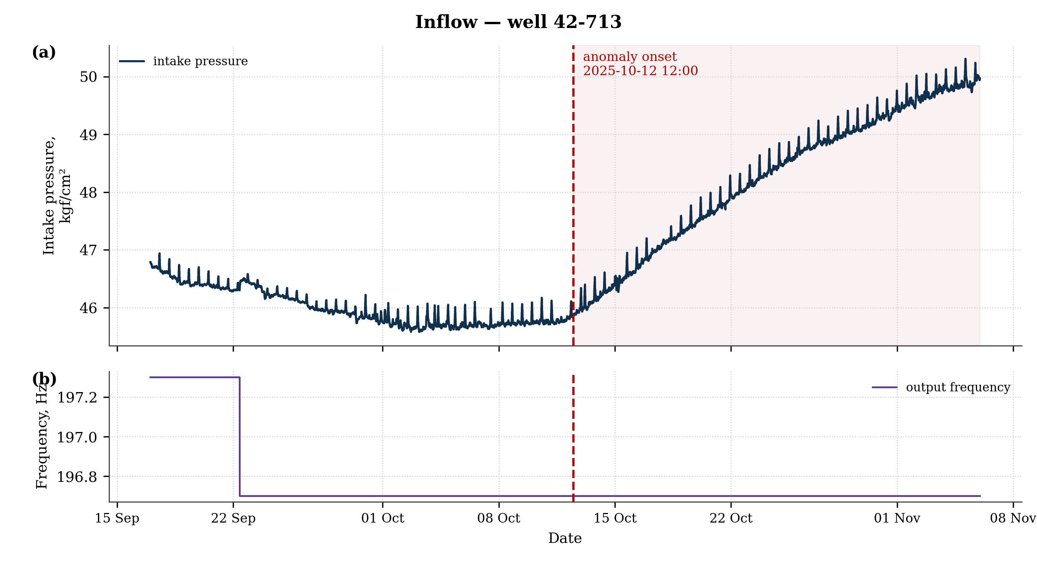
Figure 1 — Inflow, well 42-713
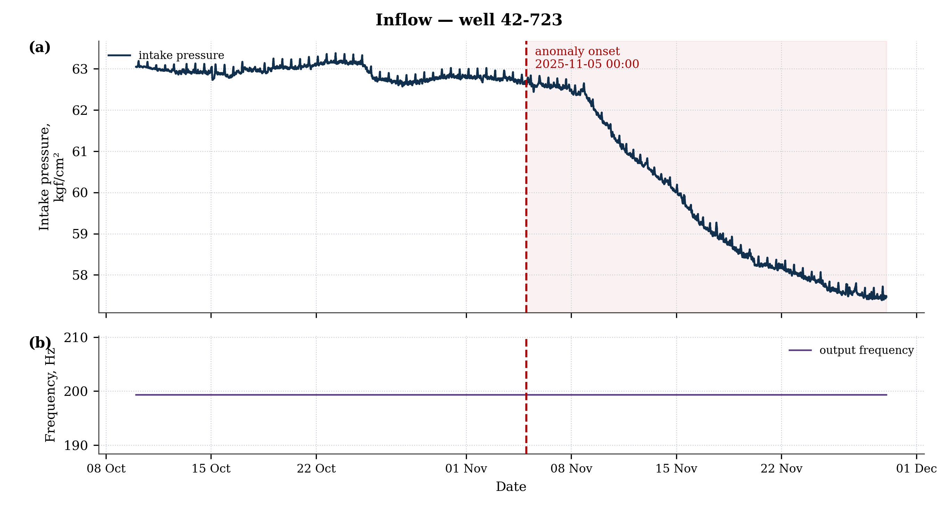
Figure 2 — Inflow, well 42-723
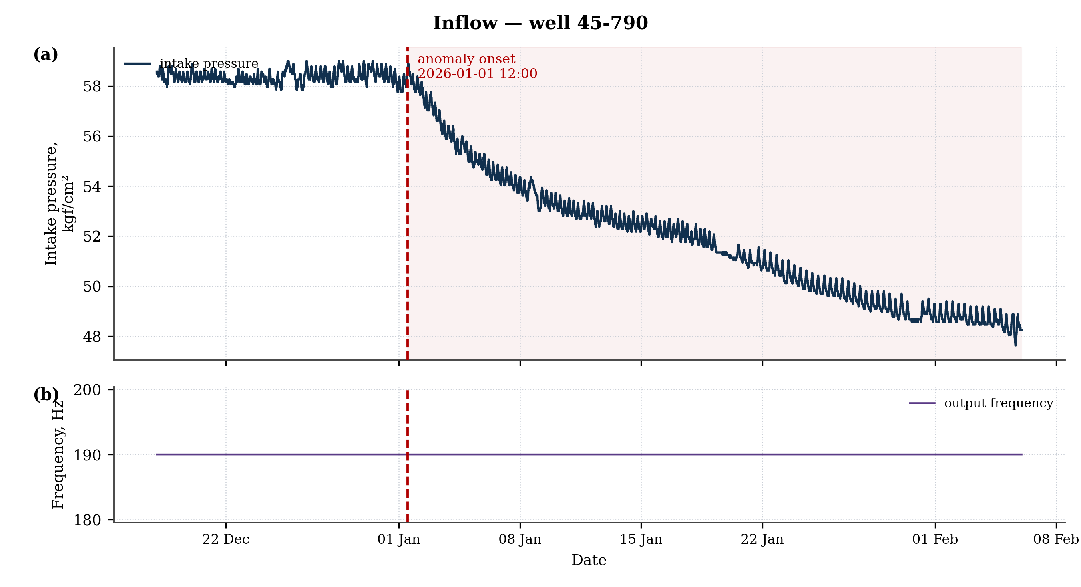
Figure 3 — Inflow, well 45-790
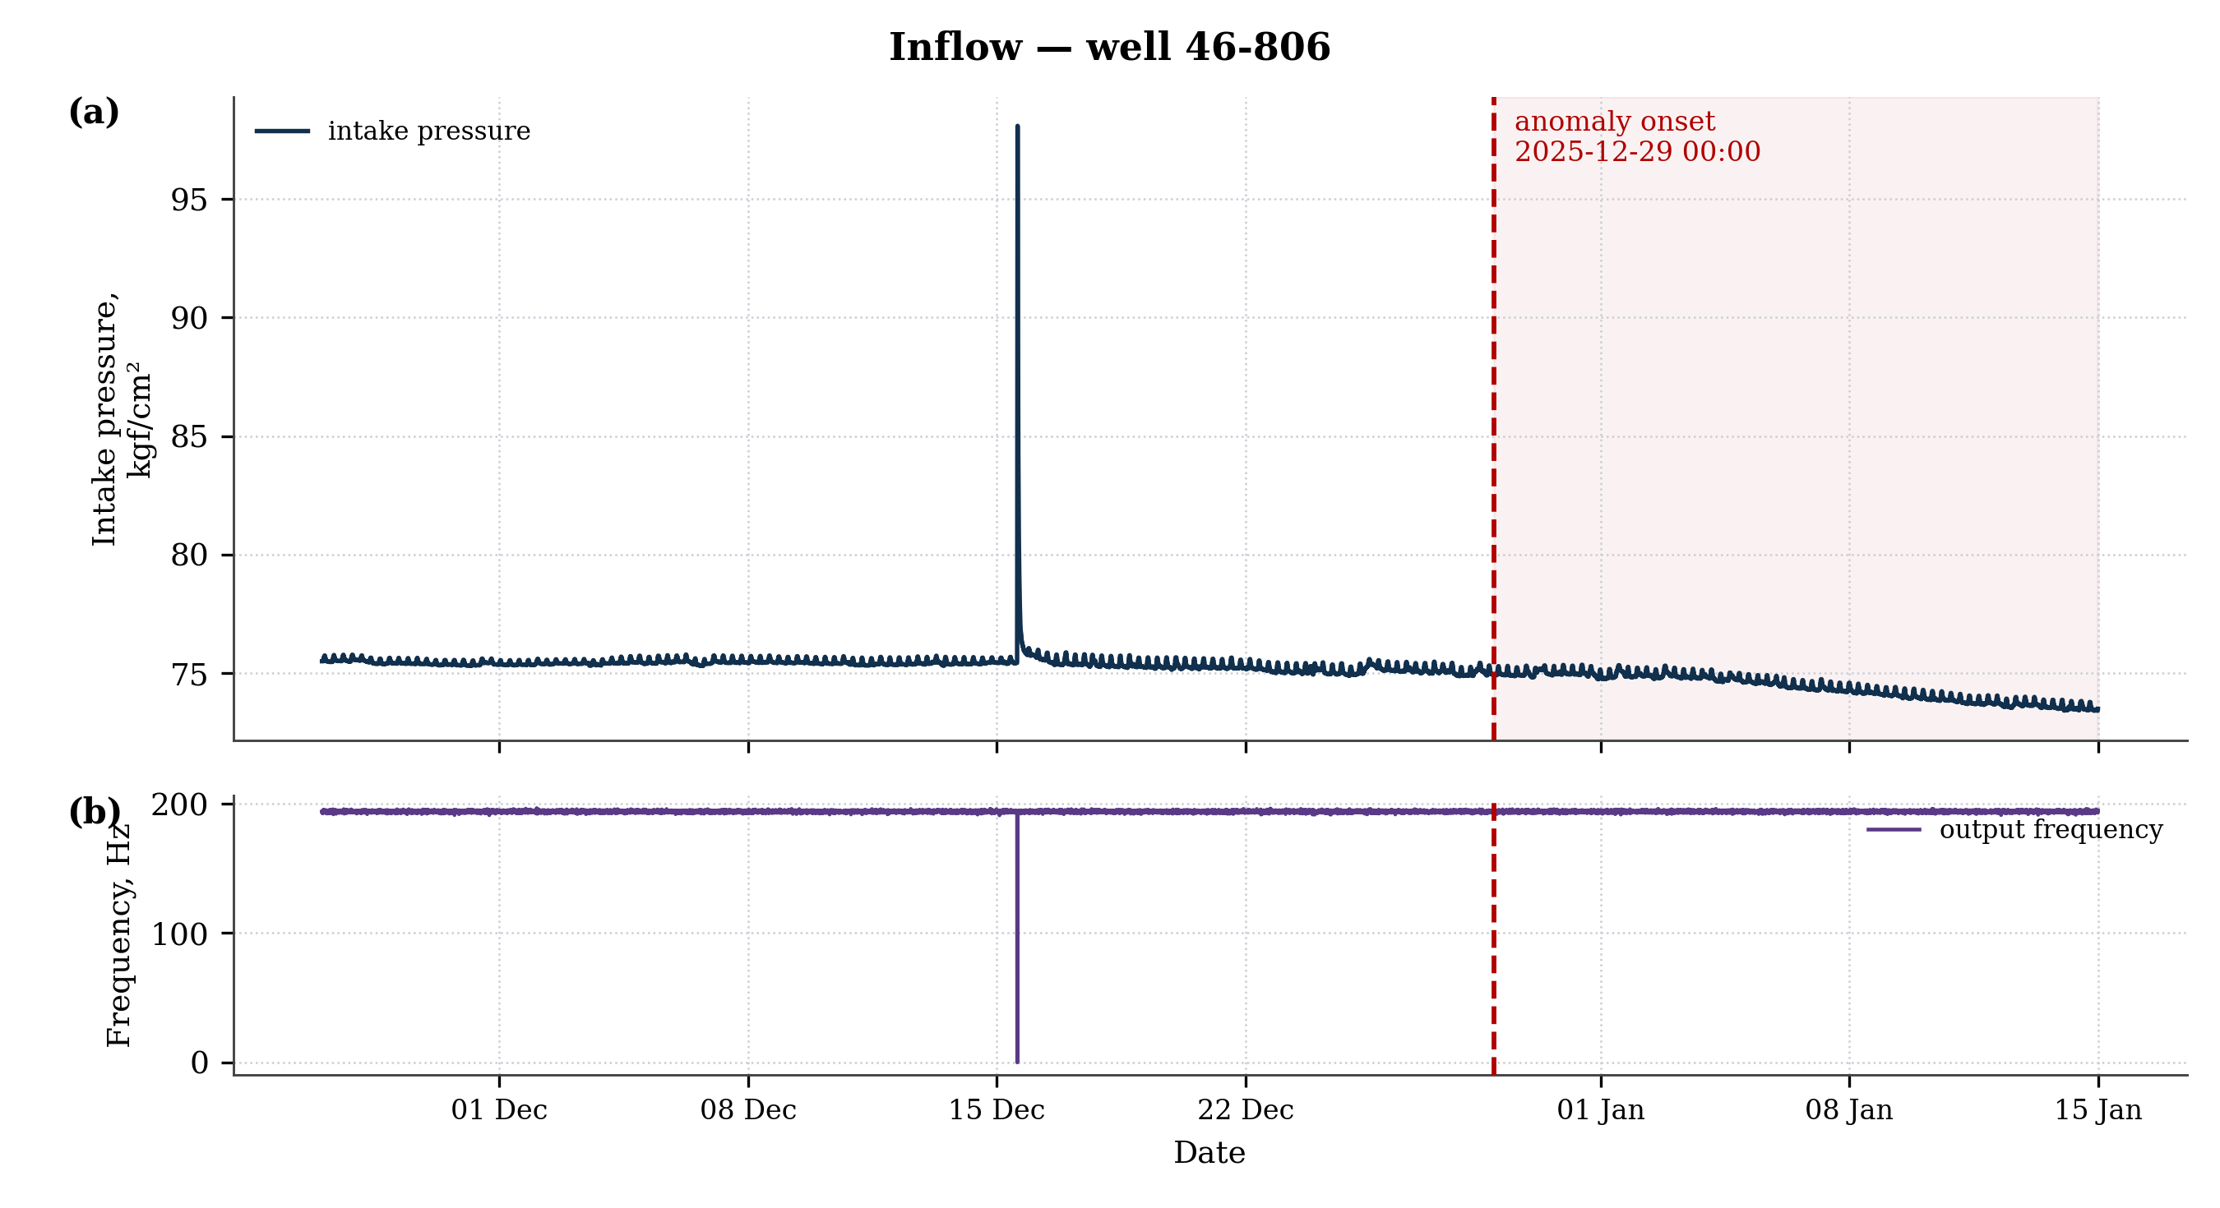
Figure 4 — Inflow, well 46-806
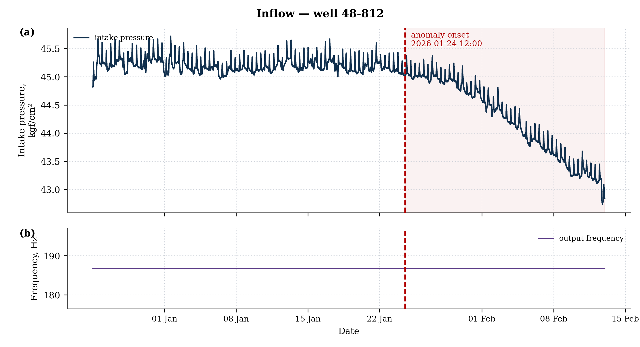
Figure 5 — Inflow, well 48-812
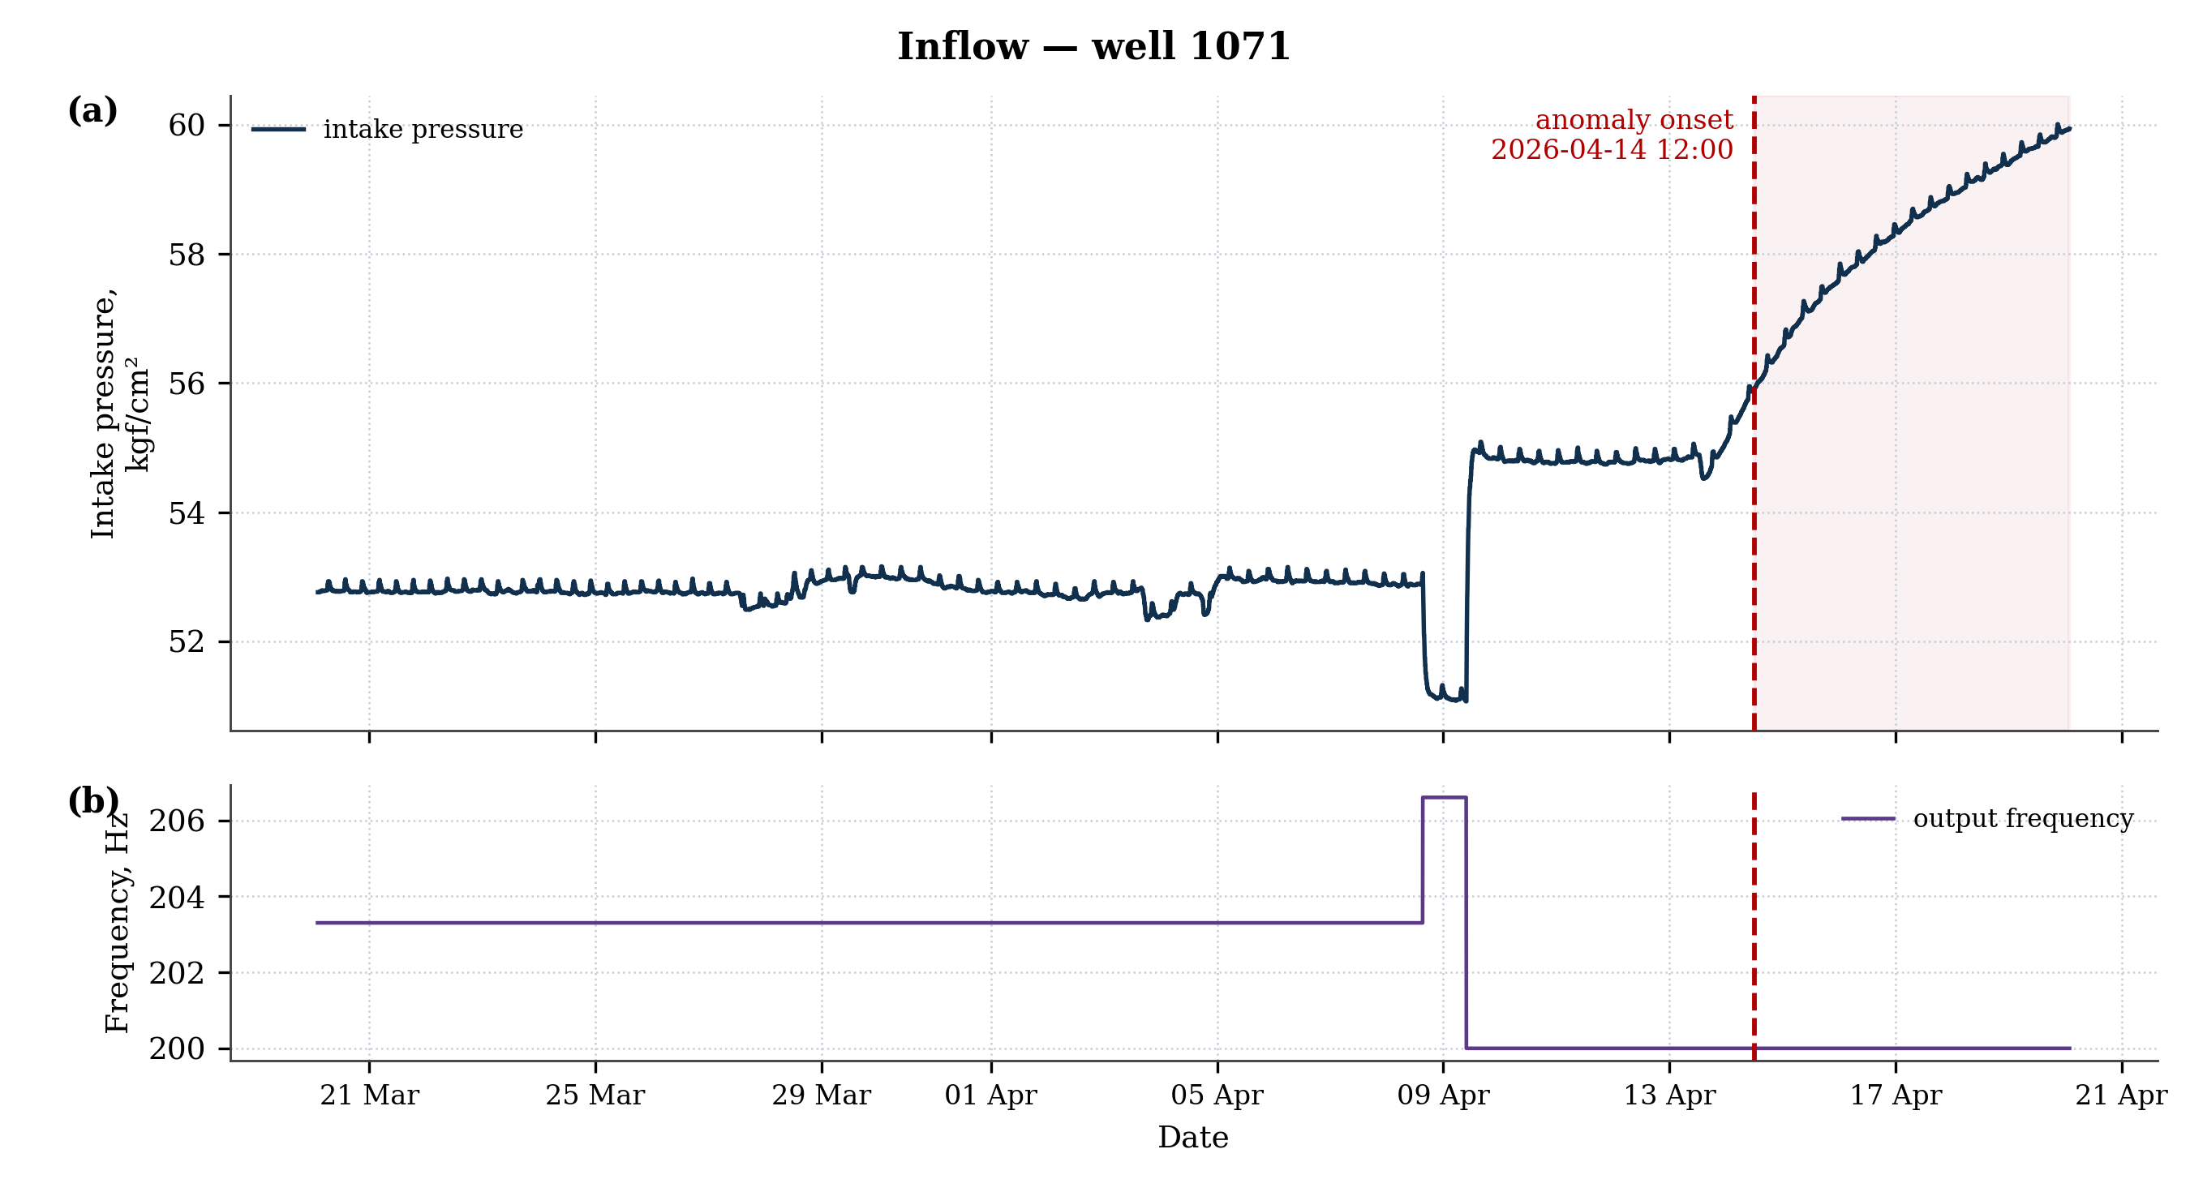
Figure 6 — Inflow, well 1071
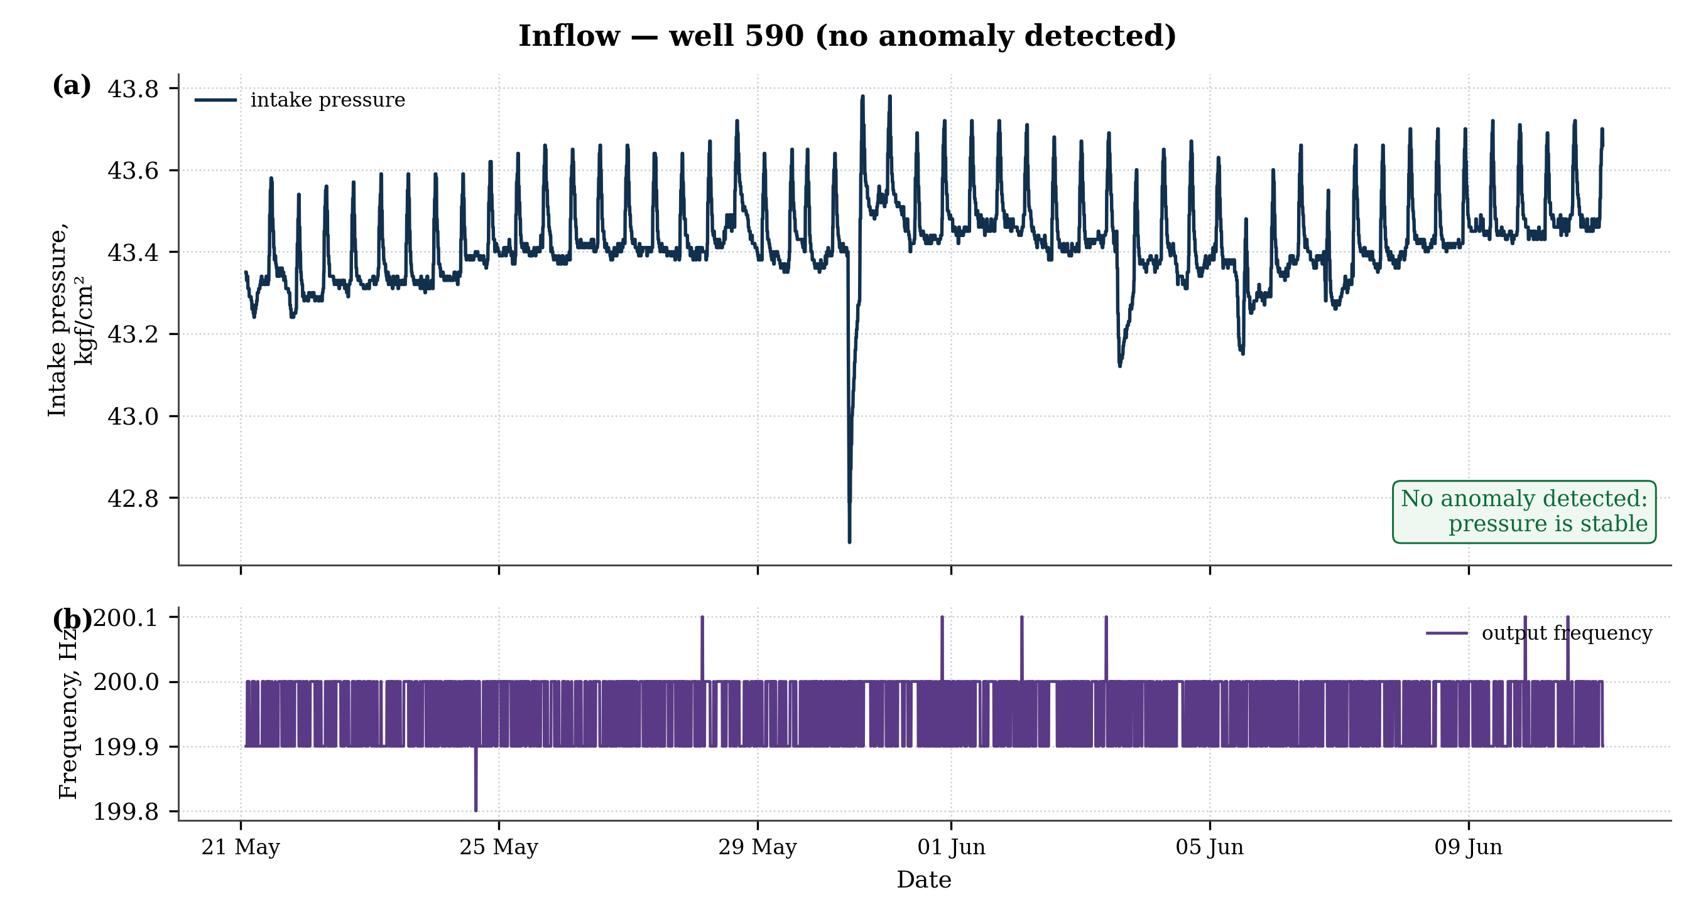
Figure 7 — Inflow, well 590 (no anomaly detected)
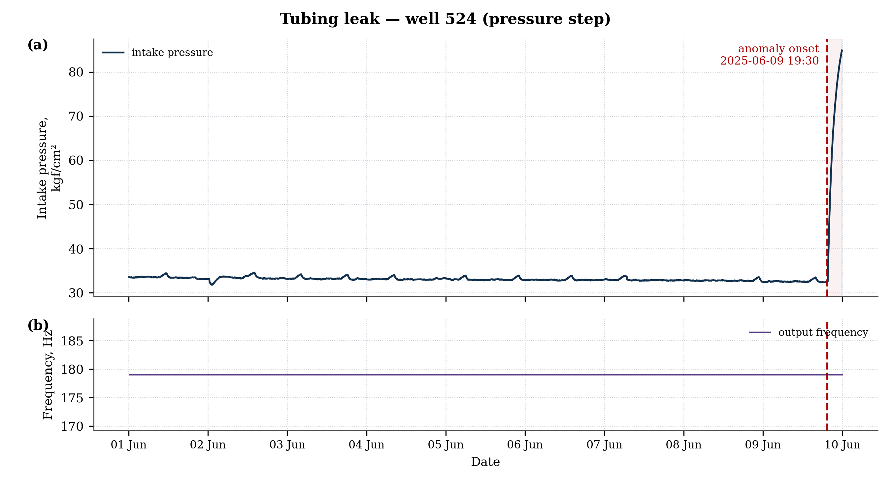
Figure 8 — Tubing leak, well 524 (pressure step)

8 Recommendations for Further Development (clause 3.6)

8.1 Expanding the List of Detected Anomalies
Adding new anomaly types (primarily scaling, for which a pilot check has already been performed), as well as other degradation modes of downhole pumping equipment.

8.2 Improving Quality for Existing Types
- Collecting exports of normal regime changes (output-frequency changes) across a larger number of wells — for more reliable separation of inflow from the normal response to a regime change.
- Per-well calibration of pressure sensitivity to frequency, storing the coefficient in the well record.

8.3 Deployment into the Production Environment
- Moving the module to online mode (real-time streaming processing of telemetry).
- Packaging the module as a service with an API and integrating it with the Customer's information systems; an operator dashboard and a trigger log.
- Automatic rejection of data artifacts (pump shutdowns, the "sawtooth" effect due to measurement units) at the preprocessing stage.
All mandatory requirements for the work product (clauses 3.1–3.6 of the Statement of Work) have been met: the module detects two agreed anomaly types, runs on the Customer's data, and is accompanied by source code, trained models, reporting materials, instructions with launch commands, test metrics, and recommendations for further development.

The PaAno architecture is a third-party open-source solution (official GitHub repository; ICLR 2026 publication). It is not the Contractor's own development; it is used in a form adapted and fine-tuned for the Customer's task.

